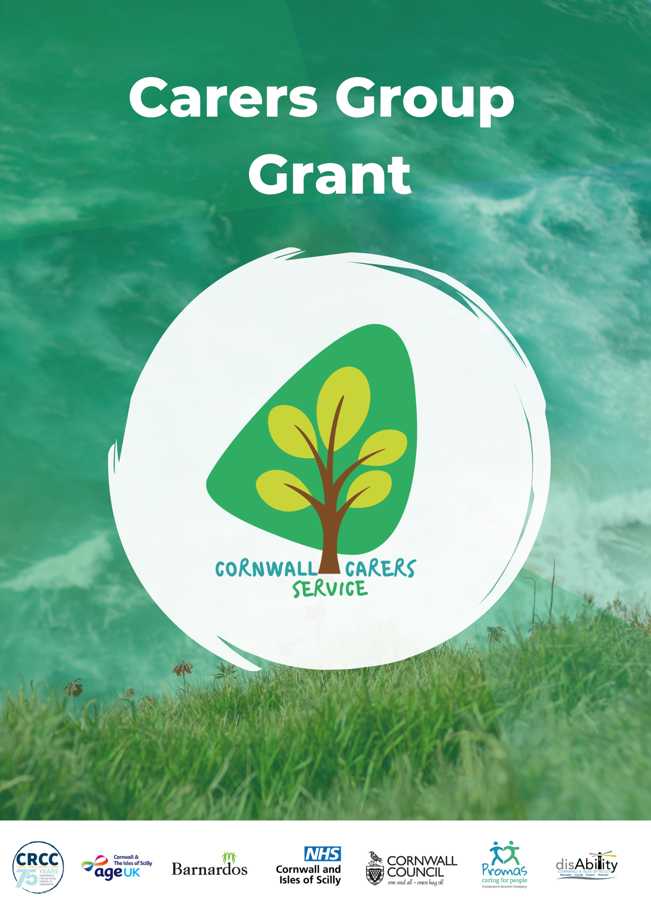

PLEASE READ THE CARERS GROUP GRANT TERMS & CONDITIONS BEFORE COMPLETING THE APPLICATION FORM
Please note, for the benefit of this grant, a formal group is one that has a group name, meets regularly throughout the year and has a bank account in the group's name.
An informal group is where individual carer friends simply wish to do something together.

GROUP/FORUM NAME
YOUR NAME or NAME OF ORGANISATION IF APPLICABLE
ADDRESS & POSTCODE
TELEPHONE NUMBER
EMAIL ADDRESS
If you are a formal group, please tick to confirm that you have Public Liability Insurance for activities & meetings  This is a requirement of funding. For new groups: this grant can fund insurance so please include this in your costings |  | ☐ Yes we have PLI  ☐ No but we are requesting funds for this in this application
Does your group have a Safeguarding Vulnerable Adults policy?  Would you like support to develop a Safeguarding policy? |  | Yes ☐ No ☐  Yes ☐ No ☐

Section 2 – About your group
Please describe your group?

How does the group support carers to improve their quality of life?
How many carers attend the group?
Please explain how your group involves its members in planning activities/funding requests.
Formal groups only are required to have a steering group or committee that oversees the grant spend, e.g. a Treasurer, Secretary, or similar. Please tell us about these people here
Name |  |  | Role
Cornwall Carers Service can provide carers with advice and guidance, the opportunity to talk with a Carer Wellbeing Practitioner and information about maximising income |  |  |  |  | ☐ Please tick if you would like us to send you information about Cornwall Carers Service

Section 3 – About your funding request

Have you had a grant from us before? |  | ☐ Yes ☐ No
How much money are you applying for?
What would you like funding for? | ☐ Activity/event costs  ☐General group running costs (e.g. room hire, insurance, etc)  ☐Start-up costs (£500 max)  ☐Tablets/mobile hub costs (additional £500 permitted for  formal groups)
How will the intended activities promote carers’ health and wellbeing and give them a break from their caring role?

If you are applying for tablets/ mobile hubs, please answer the 4 questions below
Please tick to confirm that the devices will be owned by the group but loaned out to members who need them to connect with other members online |  | ☐ Yes
Please tick to confirm that members will be supported to understand internet safety and connect online safely |  | ☐ Yes
Please explain why other sources of funding for these items are not available or applicable
How will carers be supported to increase their skills and independence to connect online

Section 4: Costings
Please list each item or activity on separate rows
Details of item or anticipated activity & website link to cost if available | Cost per person/ session/item | Number of carers | TOTAL  COST

Section 5 – Your bank details
If your application is successful, payment will be made directly into your bank account.

NAME OF ACCOUNT HOLDER (exactly as it appears on your bank account)
BANK ACCOUNT NUMBER
SORT CODE

Section 6 –Reference
All groups applying to the grant must provide a reference, on the form provided at the end of this application form, from a local professional or local recognised organisation who can vouch for/endorse the aims, objectives and support mechanisms of the group.

Section 7 – Declaration and agreement
Please tick all boxes to indicate your agreement
☐I confirm that I have read, understand and agree to the Terms & Conditions of the Carers Groups Grant
☐ I confirm that the information provided in this application is true and accurate to the best of my knowledge.

Name
Signature (Digital is acceptable)
Date

Please email your completed application form and evidence of cost to: grants@cornwallrcc.org.uk
If you need to call us, our number is: 01736 756655

For Carers Service updates please see our website Cornwall Carers Service

CARERS GROUP/FORUM GRANT REFERENCE
Name of Group
Your name
Phone number(s)
Email address
Organisation Name & Address
How do you know the applicant
Please tell us why you are supporting this application.

Signature
(electronic is acceptable)
Date

Terms & Conditions

- The purpose of the Carers Group Grant, which is commissioned by Cornwall Council and NHS Cornwall & The Isles of Scilly ICB, is to fund groups or organisations, both formal and informal, that provide support to unpaid informal carers to:
- Provide carers access to activities and support
- Assist the development and sustainability of self-support groups
- Support groups to help carers to self-manage their health and wellbeing, reduce isolation, increase confidence and improve independent living skills
Groups can apply for up to £1000 per application, with a maximum of £100 per carer. You may apply more than once per year but the annual total must not exceed £3500. New groups can apply for up to £500 towards their start-up costs, then apply for further funds later. Groups may also apply for an additional amount of up to £500 if they are purchasing internet enabled devices to be loaned out to group members

Eligibility Criteria
- Groups must have a minimum of 4 people
- Groups must be based in Cornwall and only benefit residents of the county
- Groups must have a referee from a professional or recognised organisation which can vouch for or provide a reference for the group.
- Formal groups must have a steering group or committee (e.g. Secretary or Treasurer) and provide details of this
- Formal groups must have Public Liability Insurance. New groups can use the grant to fund this.
- Groups can apply for a grant to a maximum of £1000 per application (max £100 per carer), to a maximum of £3500 per 12 month period
- Formal groups (with a group bank account and a committee) may also apply for an additional amount of up to £500 if they are purchasing internet enabled devices to be loaned out to group members
- New groups can initially apply for a start-up grant of £500 for ongoing running costs then apply again at a later date for further funds if required.
- Groups must not be commissioned by Cornwall Council, IOS Council or NHS Cornwall & The Isles of Scilly ICB
- If your planned activity changes and you wish to amend your original activity please email us at grants@cornwallrcc.org.uk with details of the changes
- Groups must submit a feedback report detailing how the grant was spent and how it has helped the group, and must provide all relevant receipts. Feedback reports must be sent back within one month of the final activity or by the end of the funding year, whichever is sooner, using the template provided at the end of this application form
- If the applicant leaves the group they must ensure that someone else in the group will take responsibility for the grant and inform CRCC of this
- If CRCC is not satisfied with how the money has been used aligned to the Terms & Conditions/purpose of the Grant, the Group may be asked to repay some or all of the grant
Exclusions (what this grant cannot pay for)
- Travel expenses, expenses to attend meetings, unless under exceptional circumstances to be agreed by the group
- Overnight accommodation costs are not permitted
- Food and drink are not permitted
- Items and activities already paid for cannot be reimbursed through this grant
- Applications from groups who have had a grant from us before and who have not submitted their feedback report and all relevant receipts.

Data Protection
CRCC complies with the EU General Data Protection Regulations and the Data Protection Act 2018. By sending this form to us, you agree that we can securely store your personal information on our database or in the form of paper records, and that we can use your information in order to provide a service to you as part of the Wellbeing Community Grants Programme.

We will only collect and process information in accordance with the legal basis for the service you are receiving. We will not sell your information or share it with any other organisations. We will not keep this information longer than necessary (this is normally for two years following the end of the contract year); it will then be securely destroyed. Our full Privacy Statement is available on request and can be viewed on our website at www.cornwallrcc.org.uk

If you wish to withdraw your consent, or if you wish to see a copy of the information we hold about you, please forward your request to the Grants and Compliance Lead at dataadmin@cornwallrcc.org.uk or call 07715 799395.

If you are unhappy with the panel’s decision
If you do not agree with the decision made by the grant panel, please contact the grant manager who will of course want to resolve any issues quickly and efficiently.
Please email Jayne.price@cornwallrcc.org.uk

Cornwall Rural Community Charity
CRCC is a Cornish charity that informs and guides local groups and individuals to achieve their aspirations and develop sustainable, inclusive communities. CRCC provides support to a wide variety of groups and individuals and embraces equality and diversity. For more information on our work, visit www.cornwallrcc.org.uk

FEEDBACK REPORT

When you applied for the Carers Groups Grant, you agreed to complete this Feedback Report and return it to us together with evidence of the spend e.g. copy receipts, invoices, etc, within the timeframe specified on your application form. In order to understand how the activity your group took part in has helped, we would like to ask you a few questions. We are passionate about assisting carers and the people they care for so all feedback is valuable and may be used to secure further funding for this particular need
Failure to submit a Grant Feedback Report with corresponding receipts may result in us asking for all or part of the grant monies to be returned and we will not be able to consider you for any future funding until this has been received.
If you need any help completing this form, please call us on 01736 756655
APPLICATION NUMBER
Did you use the money for anything that wasn't specified in your application form? If yes, please tell us what you did differently.

What has the grant been spent on?
Please give us a breakdown of what your grant was spent on below, also indicating if receipts enclosed (if not please explain why)

Item/ activity | Actual Expenditure (£) | Receipts enclosed – please tick
 |  | ☐
 |  | ☐
 |  | ☐
 |  | ☐
 |  | ☐
 |  | ☐
 |  | ☐
 |  | ☐
 |  | ☐
 | Total:

How has the grant helped your group?

Please tell us how the grant has helped your members health and wellbeing and what difference this has made to them, e.g. their quality of life has improved, they are better able to cope with their caring role, they are more supported, less isolated, etcPlease do not give any specific medical information, e.g. a health diagnosis as, under EU General Data Protection Regulations (2018) we are not permitted to hold this information

Please include anonymous feedback/quotes from group members where available
Has this grant activity or item… | Very much so | A little | Neutral | Not much | Not at all
Improved quality of life for the carers | ☐ | ☐ | ☐ | ☐ | ☐
Reduced the need for additional support | ☐ | ☐ | ☐ | ☐ | ☐

If you feel this grant programme could be improved, please tell us how?

CARER STORIES

- We would love to hear more about the impact that caring has on carers’ health and wellbeing and how this grant has helped them. The more detail a carer is able to give us, the better. If you would be kind enough to tell us more, we can use this information (anonymously) to show Cornwall Council and NHS Cornwall & The Isles of Scilly ICB
how vital this grant is in supporting carers.

Please note, you do not have to complete this section.

Please could you tell us a little bit about your caring role and how this affects your own health and wellbeing.
Please do not give any specific medical information, e.g. a health diagnosis as, under EU General Data Protection Regulations (2018) we are not permitted to hold this information.

How did the support received from your Carers Group help you with your role as a carer?
How does this group support your health and wellbeing?
What difference has it made to you?

Thank you for completing this report. Please return to: grants@cornwallrcc.org.uk

