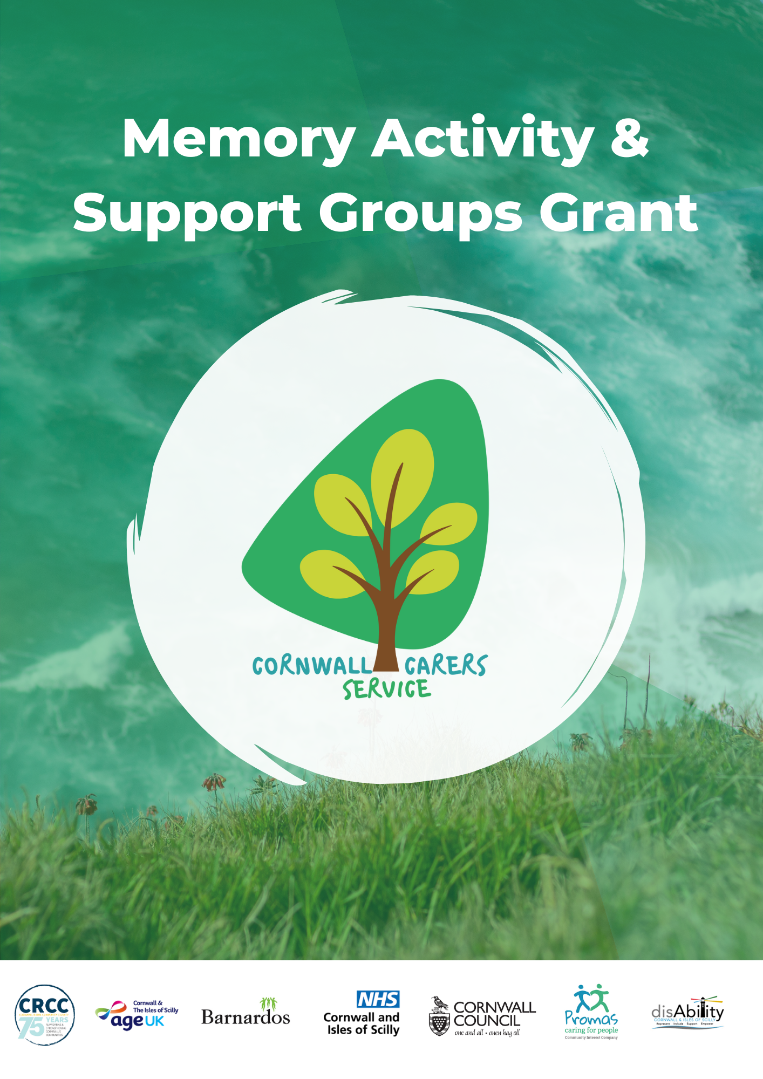

PLEASE READ THE MEMORY ACTIVITY & SUPPORT GROUP GRANT TERMS & CONDITIONS BEFORE COMPLETING THE APPLICATION FORM
Please note, for the benefit of this grant, a formal group is one that has a group name, meets regularly throughout the year and has a bank account in the group's name.
An informal group is where individual friends simply wish to do something together not linked to the Cornwall Memory Café Network

Section 1 – Contact Information Contact details
GROUP NAME
YOUR NAME OR NAME OF ORGANISATION IF APPLICABLE
ADDRESS & POSTCODE
TELEPHONE NUMBER
EMAIL ADDRESS
If you are a formal group, please tick to confirm that you have Public Liability Insurance for activities & meetings  This is a requirement of funding and can be included in the application. PLEASE NOTE IF YOU ARE A MEMBER OF THE CORNWALL MEMORY CAFÉ NETWORK YOU SHOULD BE COVERED BY THEIR INSURANCE |  | ☐ Yes we have PLI  ☐ We are a member of CMCN  ☐No but we are requesting funds for this in this application
Does your group have a Safeguarding Vulnerable Adults policy?  Would you like support to develop a Safeguarding policy? |  | Yes ☐ No ☐  Yes ☐ No ☐

Section 2 – About your group
Please describe your group

How does the group support members with memory impairment to improve their quality of life?
How many members with memory impairment attend the group?
Please explain how your group involves its members in planning activities/funding requests
Formal groups are required to have a steering group or committee that oversees the grant spend, e.g. Treasurer or Secretary. Please tell us about these people here
Name |  |  | Role
Cornwall Carers Service can provide carers with advice and guidance, the opportunity to talk with a Carer Wellbeing Practitioner and information about maximising income |  |  |  | ☐ Please tick if you would like us to send you information about Cornwall Carers Service

Section 3 – About your funding request

Have you had a grant from us before? |  |  |  | ☐Yes ☐ No
How much money are you applying for? |  |  |  | £
What would you like funding for? | ☐General group running costs (e.g. room hire, insurance, etc)  ☐Activity/event costs  ☐Start-up costs (£500 max)  ☐Tablets / mobile hub costs (additional £500 permitted for formal groups) For use of group members within the group setting
How will these items/activities support people with memory impairment?
If you are applying for tablets/ mobile hubs, please answer the 4 questions below
Please confirm that the devices will be owned by the group for use within the group environment |  |  | ☐ Yes
Please explain why other sources of funding for these items are not available or applicable
Please explain how members will be supported to enhance their skills and independence to connect online at home

Section 4: Costings
Please list each item or activity on separate rows and include evidence of cost if available
Details of item or activity requested & website link to cost if available | Cost per person/  session/item | Number benefitting | TOTAL COST
Total |  |  | £

Section 5 – Your bank details
If your application is successful, payment will be made directly into your bank account.

NAME OF ACCOUNT HOLDER (exactly as it appears on your bank account)
BANK ACCOUNT NUMBER
SORT CODE

Section 6 –Reference
All groups applying to the grant must provide a reference, on the form provided at the end of this application form, from a local professional or local recognised organisation who can vouch for/endorse the aims, objectives and support mechanisms of the group. Please note if your group is a member of the Cornwall Memory Café Network you do not need to provide a reference

Section 7 – Declaration and agreement
☐I confirm that I have read, understand and agree to the Terms & Conditions of the Memory and Support Groups Grant
☐ I confirm that the information provided in this application is true and accurate to the best of my knowledge.

Name
Signature
Date

Please email your completed application form and evidence of cost to: grants@cornwallrcc.org.uk
If you need to call us, our number is: 01736 756655

MEMORY ACTIVITY & SUPPORT GROUP GRANT REFERENCE
Name of Group
Your name
Phone number(s)
Email address
Organisation Name & Address
How do you know the applicant
Please tell us why you are supporting this application.

Signature
(electronic is acceptable)
Date

TERMS & CONDITIONS
The purpose of the Memory Activity & Support Groups Grant, which is commissioned by Cornwall Council and NHS Cornwall & The Isles of Scilly ICB, is to fund groups and organisations that support people with memory impairment and memory cafés. It can award funds towards a group’s running costs, including workshops and activities that enhance the wellbeing of members to
- provide those living with memory impairment access to activities and support
- assist the development and sustainability of self-support groups
- support groups to help people to self-manage their health and wellbeing, improve people’s experience of care, reduce social isolation, increase confidence and improve independent living skills

Eligibility Criteria
- Groups must have a minimum of 4 members
- Groups must be based in Cornwall and only benefit residents of the county.
- Groups must have a referee from a professional or recognised organisation that can vouch for or provide a reference for the group.
- Formal groups must have a steering group or committee (e.g. Secretary or Treasurer) and provide details of this.
- Formal groups must have Public Liability Insurance. New groups can use the grant to fund this.
- Groups can apply for a grant to a maximum of £1000 per 12 month period
- Formal groups (with a group bank account and a committee) may also apply for an additional amount of up to £500 if they are purchasing internet-enabled devices to be used by members in the group environment
- New groups can initially apply for a start-up grant of £500 for ongoing running costs then apply again at a later date for further funds if required.
- Organisations must not be commissioned by Cornwall Council, IOS Council or NHS Cornwall & The Isles of Scilly ICB to provide these activities
- If your planned activity changes and you wish to amend your original activity please email us at grants@cornwallrcc.org.uk with details of the changes
- Groups must submit a feedback report detailing how the grant was spent and how it has helped the group, and must provide all relevant receipts. Feedback reports must be sent back within one month of the final activity or by the end of the funding year, whichever is sooner, using the template provided at the end of this application form
- If the applicant leaves the group they must ensure that someone else in the group will take responsibility for the grant and inform CRCC of this
- If CRCC is not satisfied with how the money has been used the Group may be asked to repay some or all of the grant.
- If CRCC is not satisfied with how the money has been used aligned to the Terms & Conditions/purpose of the Grant, the Group may be asked to repay some or all of the grant
Exclusions (what this grant cannot pay for)
- Travel expenses, expenses to attend meetings, unless under exceptional circumstances to be agreed by the group.
- Overnight accommodation costs are not permitted.
- Food and drink are not permitted.
- Items and activities already paid for cannot be reimbursed through this grant.
- Applications from groups who have had a grant from us before and who have not submitted their feedback report and all relevant receipts cannot be considered

Data Protection
CRCC complies with the EU General Data Protection Regulations and the Data Protection Act 2018. By sending this form to us, you agree that we can securely store your personal information on our database or in the form of paper records, and that we can use your information in order to provide a service to you as part of the Wellbeing Community Grants Programme.

We will only collect and process information in accordance with the legal basis for the service you are receiving. We will not sell your information or share it with any other organisations. We will not keep this information longer than necessary (this is normally for two years following the end of the contract year); it will then be securely destroyed. Our full Privacy Statement is available on request and can be viewed on our website at www.cornwallrcc.org.uk

If you wish to withdraw your consent, or if you wish to see a copy of the information we hold about you, please forward your request to the Grants and Compliance Lead at dataadmin@cornwallrcc.org.uk or call 07715 799395

If you are unhappy with the panel’s decision
If you do not agree with the decision made by the grant panel please contact the grant manager. who will of course want to resolve any issues quickly and efficiently.
Please email: Jayne.price@cornwallrcc.org.uk

Cornwall Rural Community Charity
CRCC is a Cornish charity that informs and guides local groups and individuals to achieve their aspirations and develop sustainable, inclusive communities. CRCC provides support to a wide variety of groups and individuals and embraces equality and diversity. For more information on our work, visit www.cornwallrcc.org.uk

FEEDBACK REPORT
When you applied for the Memory Activity and Support Groups Grant, you agreed to complete this Feedback Report and return it to us, together with evidence of the spend e.g. copy receipts, invoices, etc, within the time frame specified on your application form. In order to understand how the grant has helped your Group, we would like to ask you a few questions. We are passionate about assisting people with memory impairment so all feedback is valuable and may be used to secure further funding for this particular need
Failure to submit a feedback report with all receipts may result in us asking for all or part of the grant monies to be returned and we will not be able to consider your group for any future funding until this is received.
If you need any help completing this form, please call us on 01736 756655

APPLICATION NUMBER
Did you use the money for anything that wasn't specified in your application form? If yes, please tell us what you did differently.

What has the grant been spent on?
Please give us a breakdown of what your grant was spent on below, also indicating if receipts enclosed (if not please explain why)

Item/ activity | Actual Expenditure (£) | Receipts enclosed – please tick
 |  | ☐
 |  | ☐
 |  | ☐
 |  | ☐
 |  | ☐
 |  | ☐
 |  | ☐
 |  | ☐
 |  | ☐
 |  | ☐
 |  | ☐
 |  | ☐
 |  | ☐
 | Total:

How has the grant helped your group?

Please tell us how the grant has helped your members health and wellbeing and what difference this has made to them, e.g. their quality of life has improved, they are more supported, less isolated, etc
Please do not give any specific medical information, e.g. a health diagnosis as, under EU General Data Protection Regulations (2018) we are not permitted to hold this information
Please include anonymous feedback/quotes from group members where available
Has this grant  activity or item | Very much so | A little | Neutral | Not much | Not at all
- Improved members  quality of life | ☐ | ☐ | ☐ | ☐ | ☐
- Reduced the need for additional support | ☐ | ☐ | ☐ | ☐ | ☐

If you feel this grant programme could be improved, please tell us how?

CARERS STORIES

- We would love to hear more about the impact your Group has had on members health and wellbeing and how this grant has helped them. If you would be kind enough to tell us more, we can use this information (anonymously) to show Cornwall Council and NHS Cornwall & The Isles of Scilly ICB how vital this grant is in supporting carers.

Please note, you do not have to complete this section

Could you give us a case study telling us a little bit about the impact that having memory impairment has had on your members general health & wellbeing.
Please do not give any specific medical information, e.g. a health diagnosis as, under EU General Data Protection Regulations (2018) we are not permitted to hold this information.

(examples can be anecdotal)

How does being part of this group support them with their health and wellbeing?
What difference has it made to them?
(examples can be anecdotal)

Thank you for completing this report. Please return to: grants@cornwallrcc.org.uk

